UNITED WOMEN OF FAITH
DRIVE-THRU SALE

They will be selling:

*16 ounce packages of Mascot Mammoth Pecan Halves - $12.00
*12 ounce packages of Chocolate Covered Pecans - $12.00
*10 ounce packages of Cinnamon Glazed Pecans - $12.00
*7-Way Tins - $30.00
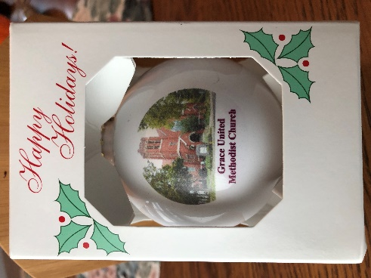 Christmas Ornament 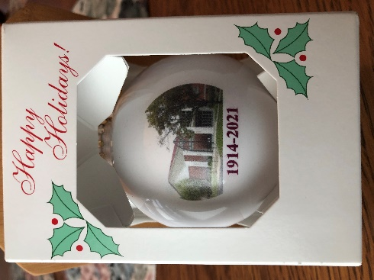
FRONT $10.00 BACK

To preorder call the Church Office @ 309-347-7131 or Carol @309-256-0075

Item Pick Ups are 9 a.m. to 1:00 p.m.
Saturday, November 12
At Grace United Methodist Church, 601 N. 4th Street, Pekin,
on a Drive-thru basis on the Henrietta Street side of the church.

PLEASE HAVE THE EXACT AMOUNT WHEN PAYING.
Checks made payable to: United Women of Faith

ALL PROCEEDS WILL BE USED TOWARD THE MISSION NEEDS OF WOMEN AND CHILDREN

